Machine learning based Buyer Segmentation and Investment Profiling for Real Estate Market Intelligence

1. Introduction
The real estate industry generates large amounts of customer and property data. Understanding buyer behaviour and investment preferences is important for making strategic business decisions. This project aims to analyse real estate buyers, identify different buyer segments, and study property investment patterns.
The project focuses on customer profiling, buyer segmentation, geographic analysis, and property investment insights to support data-driven decision-making.

2. Project Objectives
The main objectives of this project are:
- Analyse buyer demographics and behaviour.
- Segment buyers into meaningful groups.
- Study property investment patterns.
- Analyse geographic distribution of buyers.
- Develop interactive dashboards for business insights.
- Generate actionable recommendations for real estate stakeholders.

3. Tools and Technologies Used

Tool Purpose
- SQL Data analysis and querying
- Excel Data cleaning and feature engineering
- Power BI Dashboard creation and visualization
4. Dataset Description
Two datasets were used in this project:
(a) Clients Dataset
Contains buyer-related information such as:
- Client ID
- Client Type
- Country
- Region
- Date of Birth
- Acquisition Purpose
- Loan Applied
- Satisfaction Score
(b) Properties Dataset
Contains property-related information such as:
- Listing ID
- Unit Category
- Sale Price
- Floor Area
- Transaction Date
- Listing Status
- Client Reference

5. Data Cleaning and Preparation
The following preprocessing steps were performed:

(a) Clients Data
- Removed duplicate records.
- Corrected date format inconsistencies.
- Created Age column using Date of Birth.
- Created Buyer Segment column.

(b)Properties Data
- Removed duplicate records.
- Verified property prices and area values.
- Checked for missing values.

6. Feature Engineering

a. Buyer Segmentation
Buyers were classified into four categories:

b. First-Time Buyers
Young customers who applied for loans.

c. Corporate Buyers
Company-based clients purchasing properties.

d. Luxury Investors
Investment-oriented buyers with high satisfaction levels.

e. Global Investors
Remaining buyers not belonging to the above categories.
7. SQL Analysis
SQL was used to perform analytical queries and for data cleaning on the datasets.
Examples of analysis performed:
a. Country wise Buyers

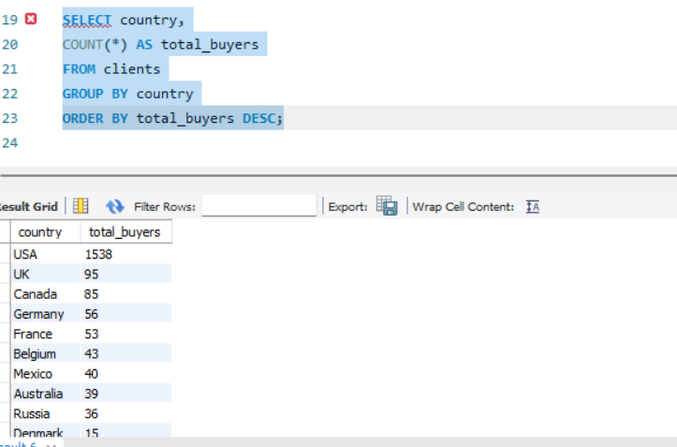
b. Loan Analysis
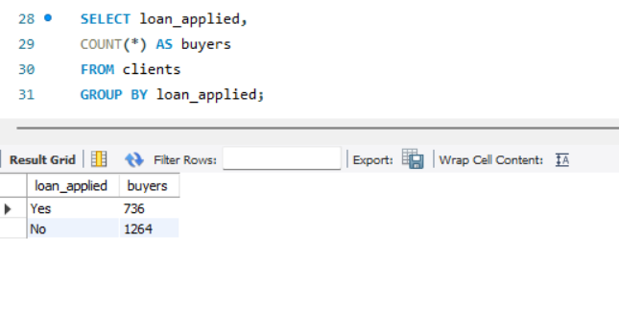
c. Average Satisfaction Score
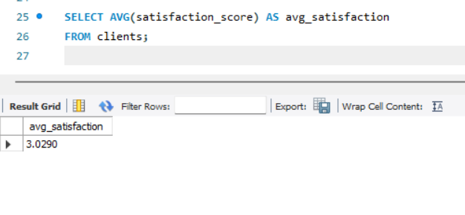
d. Acquisition Purpose Analysis
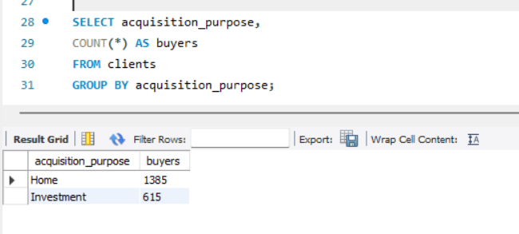
e. Total Client Type Analysis
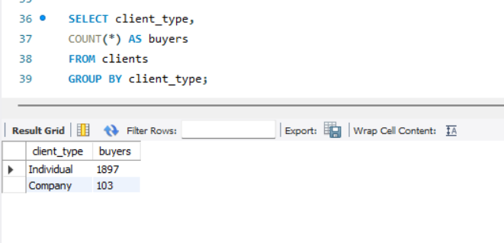
f. Total clients
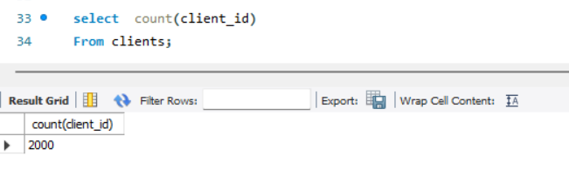
g. Replaced “M” with “Male” and “F” with “Female”
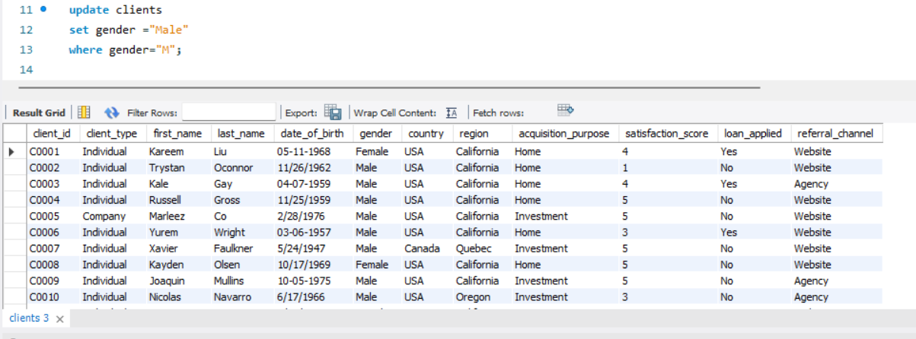

h. Category wise properties
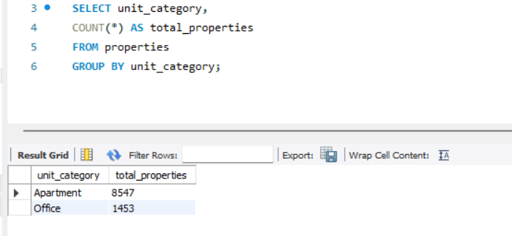

8. Dashboard Development
An interactive Power BI dashboard was developed consisting of four modules.

Module 1: Buyer Segmentation Overview
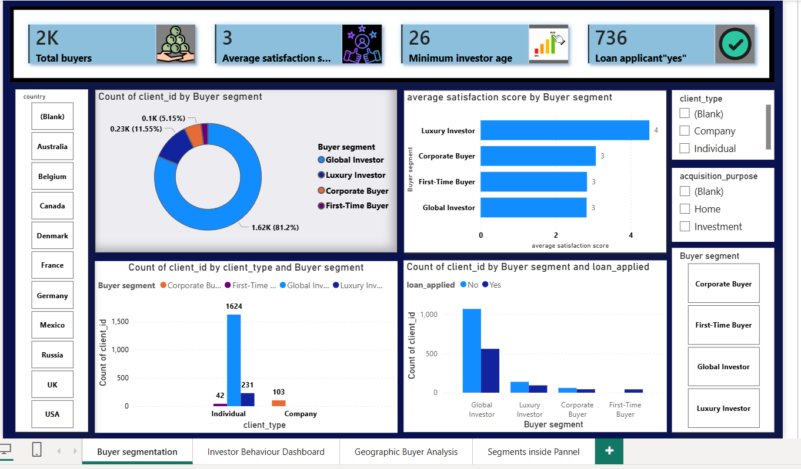
Module 2: Investor Behaviour Dashboard
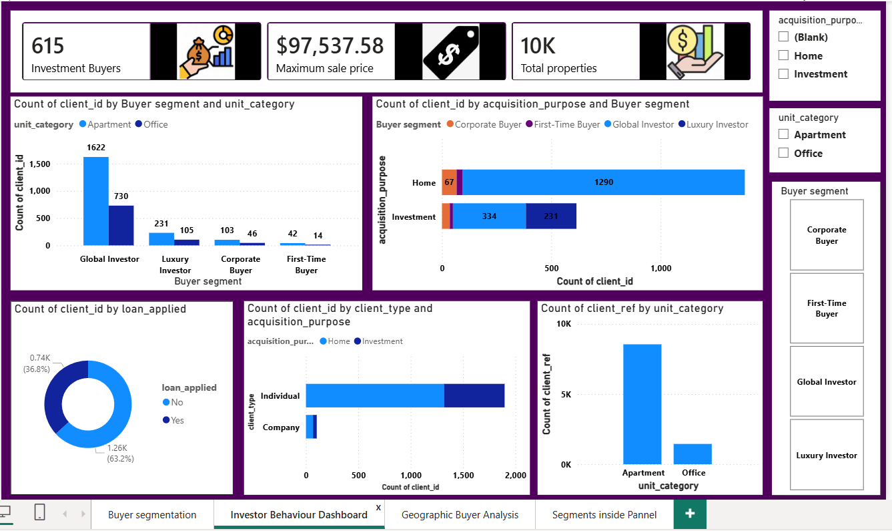

Module 3: Geographic Buyer Analysis
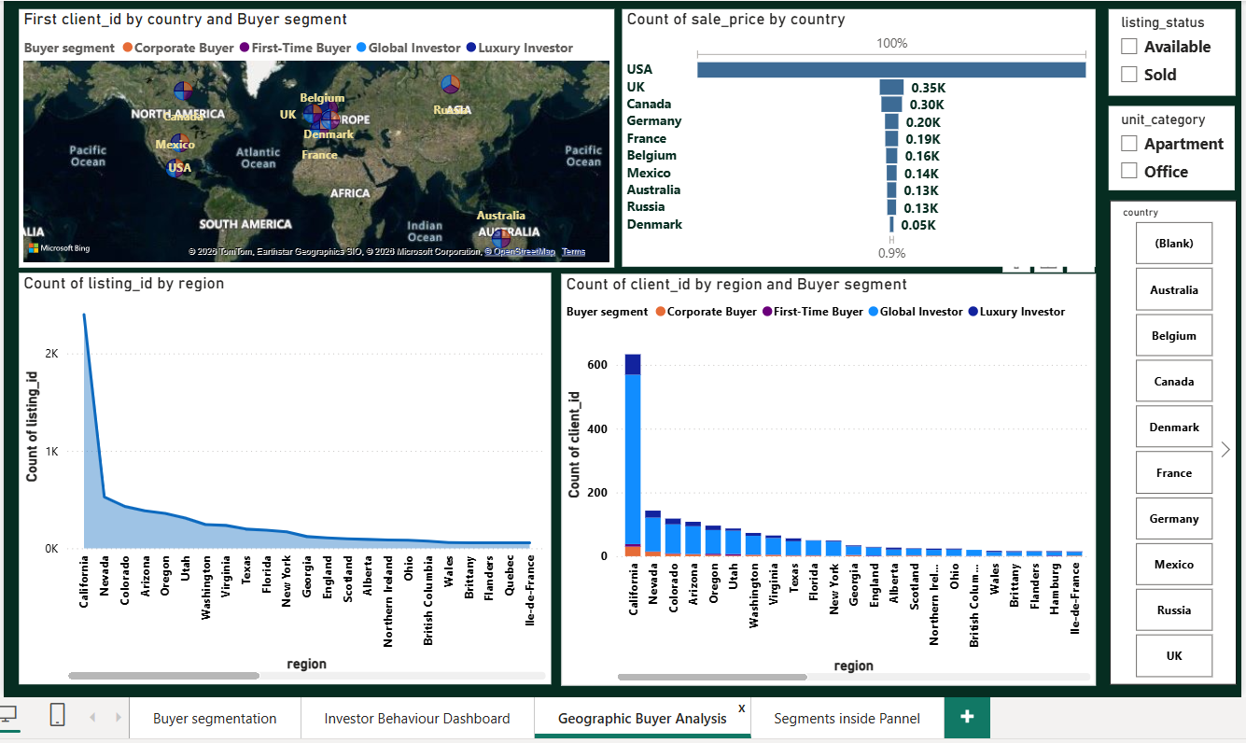

Module 4: Segment Insights Panel
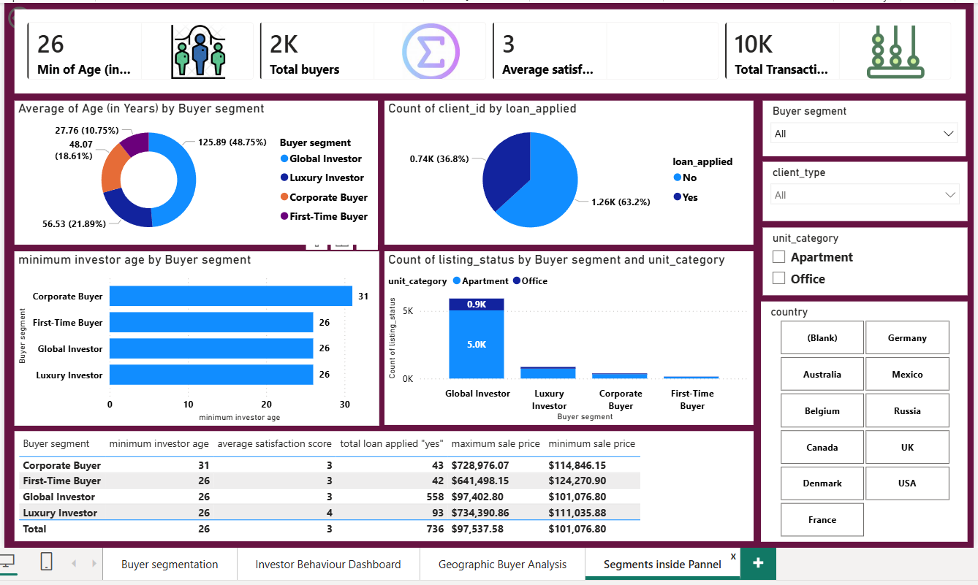

9.Key Findings

1. Global investor account for approximately 81% of total buyer (1624 buyers) , making them the largest customer segment

2. Luxury investors have the highest satisfaction level score of 4 , indicating a more positive customer experience compared to others.

3.Out of 2,000 buyers, only 736 buyers applied for loan , while the majority purchased without financial support.

4. Apartments are the most preferred property type.

5. Most investment-related acquisitions were made by Global Investors and Luxury Investors, indicating strong investment activity within these segments.

6. The majority of purchases were made by individual clients rather than company clients, highlighting the importance of targeting individual customers.

7. California has the highest concentration of property listings and buyers, making it the most active region in the dataset.

8. USA contributes the highest total sale price, outperforming all other countries in the dataset.

9. Global Investors hold the largest number of properties, while First-Time Buyers and Corporate Buyers represent smaller but strategically important segments.

10. Business Recommendations

Recommendation 1
Develop targeted marketing campaigns for Global Investors since they represent the largest customer segment.

Recommendation 2
Expand apartment inventory because apartments are the most preferred property category.

Recommendation 3
Focus investment-oriented promotional campaigns on Luxury Investors and Global Investors.

Recommendation 4
Strengthen customer service programs to improve satisfaction among First-Time and Corporate Buyers.

Recommendation 5
Increase property development and marketing efforts in California and other high-performing regions.

11. Conclusion
This project successfully analysed real estate buyer behaviour and property investment patterns. Buyer segmentation techniques were used to classify customers into Global Investors, Luxury Investors, Corporate Buyers, and First-Time Buyers. Interactive dashboards were developed to analyse buyer demographics, investment behaviour, geographic trends, and segment-level insights.
The analysis revealed that Global Investors form the largest buyer group, apartments are the most preferred property type, and California is the leading region in terms of buyer activity. The dashboards provide actionable insights that can help real estate organizations improve customer targeting, optimize investment strategies, and support data-driven decision-making.

